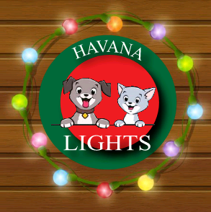  2048 Havana Rd  Owatonna, MN  Drive thru Christmas Light Display  Havana Lights is a drive-thru Christmas light display. It is free & open to the public, however, a free will donation of money, cat or dog food, or kitty litter, would be appreciated and will go towards the efforts of Helping Paws of Southern MN, which is a 501(c) non-profit, they do rescue and TNR (Trap/Neuter/Return or Re-home). Other items could be: Toys, treats or beds (place in containers provided). (Make checks payable to Helping Paws of Southern MN).  Web: havanalights.wixsite.com/havanalights  E-Mail: havanalights@outlook.com Like us on Facebook | Drive thru Christmas light display. Free and open to the public  ────  From I-35 take exit #40A onto Hwy 14 & head East. Take Hwy 218 exit. At the stop sign turn left & head North on Cty Rd 48 (Bixby Rd). Drive 1 mile & turn right (East) onto Havana Rd (Cty Rd 171), drive ½ mile  ────  Dusk - 10:00 pm  ────  Thanksgiving –  New Year’s  ────  Merry Christmas & Happy New Year!

